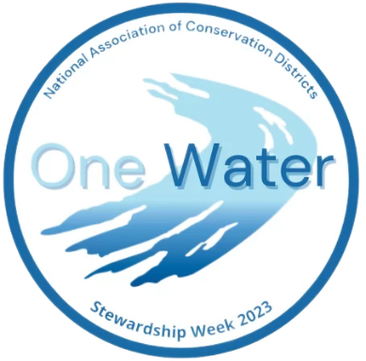
Announcing the National Association of Conservation Districts (NACD) Annual Poster Contest

Oneida County Soil & Water Conservation District is participating in this year’s NACD poster contest. This means that all school age children within Oneida County between Kindergarten and 12th grade are welcome to be part of our competition. This applies to homeschool, public and private school children. (Contact your local SWCD if you are outside Oneida County.)

The rules:
- Poster size 14” x 22”.
- Use a white posterboard, no fluorescent boards.
- This year’s theme “Watersheds – One Water”, should be on the poster.
- Must be artist’s original creation.
- Filled out entry form must be attached to the back of the poster.
- Any media can be used, markers, crayons, pencils, charcoal, stickers, paper, etc.
- Poster must be flat, not 3D.
Posters are judged by grades as follows:
K -1st
2nd – 3rd
4th – 6th
7th – 9th
10th- 12th

Deadline for this contest is Thursday July 20^{th.}
The winners from Oneida County will be sent to NYACD and the state winners will go to NACD.
The final contest winners will be announced at the NACD Annual Meeting in February 2024.

NACD prizes: $200 for 1st place winners
$150 for 2nd place winners
$100 for 3rd place winners

Posters must be submitted to:
Oneida County Soil & Water Conservation District
121 Second St, Oriskany, NY
Contact is Jessica Pyrda, 315-736-3334 x 138 or jessica.pryda@oneidacountyswcd.org

More information:
2023NACD Poster PowerPoint Guide

You need this >>>>2021-Poster-Contest-Entry-Form_Local-Competition.pdf (nacdnet.org) <<<<<

